FINANCIAL MANAGEMENT

Student Name:

Institution Affiliation:

Executive Summary
The following project was carried out to determine the cost of debt, cost of preferred stock, cost of common equity, capital structure, and the weighted average cost of capital (WACC) for FORD Motor Company. Following the analysis of the relevant data dated 2019 from different sources as shown in this report, the following results were obtained.
The percentage cost of debt was marked at3.26% with FORD cost of debt being 5,150,930,400. The percentage cost of equity was earmarked at 4.719% using the Capital Asset Pricing Model (CAPM) while the overall weighted cost of equity stood at 5.3427%.
The weighted Average Cost of Capital (WACC) using the book values from FORD balance sheet 2019 was 3.6267% while the WACC using the available market value was calculated to be 4.935% as of the year ending 2019.

QUESTION 2
Component Cost of Capital Estimation

FORD - Cost of Debt
According to Stock analysis on net,the debt (Carrying amount) of FORD as of the financial year ending 2019 was 155,307,000,000 $ whereas the debt (fair amount) was 158,004,000,000 $. The financial ratio of debt, fair value to carrying amount ratio was 1.02.
The debt (fair amount) was further categorized as shown in the table below.
DEBT | AMOUNT
Automotive debt | 15,606,000,000
credit debt | 141,678,000,000
Other debt | 720,000,000
Total debt (Fair value) | 158,004,000,000

TABLE 1: FORD total debt (Fair value)
According to the same source, the weighted-average effective interest rate on the debt of Ford is 3.26 %. Therefore, the cost of debt of FORD will be;
158,004,000,000 *0.0326 = 5,150,930,400
Cost of debt of the financial year 2019 is 5,150,930,400

FORD- Cost of Equity
To determine the above value, the cost of equity was calculated using three methods, the capital-asset pricing model (CAPM), discount-credited formulae (DCF), and bond-yield-plus-risk-premium. The weighted average of the three methods was then determined.
Capital Asset Pricing Model (CAPM) Method.
The CAPM model requires the use of the following formulae:
R_{a} = R_{rf} + beta_{a} * (R _{m}-R_{r f})
WHERE;
R_{a} = Expected return on a security
R_{r f} = Risk-free rate
R_{m} = Expected return of the market
Beta_{a}= the Beta of the security
(R_{m}–R_{rf}) = Equity market premium
The beta determines the stock’s relative volatility. The calculations for the value of beta was done in a separate excel sheet. The data used was retrieved from the Yahoo finance website. According to the regression data analysis carried out, the value for beta is 1.228966. According to Gurufocus.com, the current risk-free rate is 0.640000% while the expected return of the market is estimated at 6.640000%. By calculation, the premium is 6%
Using the above following values, we calculate the cost of equity as;
0.64 + 1.228966 * (6) = 4.71922944 %

Discounted Cash Flow (DCF) Method.
According to the website Macrotrends.net, the annual cash flow for the year ending 2019 of Ford was 10,007,000,000. The cost of as calculated using this method was found to be 5.00467834.
Bond-Yield-plus-Risk-Premium Method
The formulae for the above-mentioned method are;
Cost of debt = Bond yield + risk premium.
The risk premium of Ford as mentioned above is 6.640000%. The bond yield for Ford is around 6.3% (investorplace). Cumulatively, the cost of debt according to this method is:
6.3 + 6.64 = 12.94%
Weighted Cost of Equity
The weighted cost of debt is calculated using the values obtained from the three methods as shown above.
Weighted Cost of debt;
(0.6666 * 4.71922944) + (0.2666 * 5.00467834) + (0.0666 * 12.94) = 5.3427523%

QUESTION 3
Estimate Capital Structure and WACC

WACC (Book Weights)
Initially, the weighted average cost of capital (WACC) was first calculated using the book values from the FORD 2019 balance sheet uploaded from Yahoo.finance. The formulae for calculating the WACC is shown below.
WACC=Equity cost + Debt cost after tax
=[(E/V) * Re] + [(D/V * Rd) * (1-T)]
Where;
E = Book value of FORD equity _ 33,185,000,000 according to Ford balance sheet 2019
D = Book value of FORD debt _ 155,307,000,000 according to Ford balance sheet 2019
V = Total market value of the company (E + D) _ 188,492,000,000
Re = % of equity _ 5.3427523%
Rd = % of debt _ 3.26%
T = Tax rate _ 21% used as the corporate tax rate. Obtained fromtradingeconomics.com.

Therefore, WACC (book value) as calculated in the attached Excel file is3.626679408%

WACC (Market Weights)
Finally, the weighted average cost of capital (WACC) was then calculated using the market weights as shown below.
Where;
E = Market value of FORD equity_ 33,000,000,000 as per statista.com.
D = Market value of FORD debt _ 155,000,000,000 as per statista.com.
V = Total market value of the company (E + D) _ 188, 000,000,000
Re = % of equity_ 12.8% as per finbox.com
Rd = % of debt _ 3.26 as per stock analysis on the net.
T = Tax rate _ 21% used as the corporate tax rate.

WACC (market weights) as calculated in the attached excel file is4.93457446808%
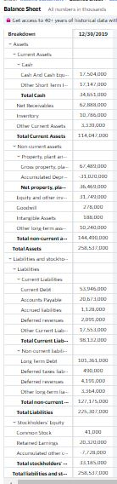
Appendices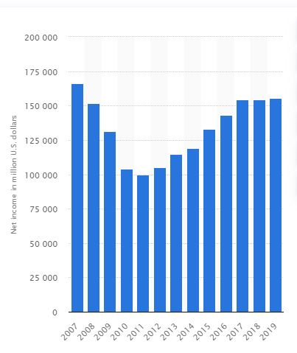
FIGURE 2: FORD debt 2007-2019
FIGURE 1: FORD balance sheet 2019

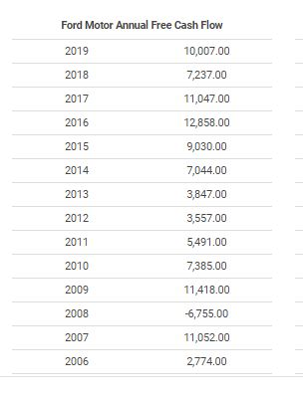
FIGURE 3: FORD annual free cash flow (2006-2019)

QUESTION 5
CAPITAL BUDGET FOR THE FORD COMPANY
Business budgeting for capital expenditures in a business project is vital for a business to process and develop from a sound capital position. Capital expenditures refer to the expenses a firm generates to make capital benefits over the years. Capital budgeting for the commence of a business is essential in any business since it aids business capability of sustaining its planned project and seek for more funds if necessary. It also aids the business to determine its cash flow payback period and its present net value
Ford’s manager should consider several things when preparing the capital budget of their next planned project. Some of the things they should consider cash flow, discounted cash flow, payback period, the capital it needs to start the business. The other things that the Ford’s manager needs to consider have been outlined below in the calculates that follows:

References
(https://finance.yahoo.com)
(https://www.finbox.net/NYSE:FORD/explorer/cost-equity)
(https://www.macrotrends.net/stocks/charts/F/ford-motor/free-cash-flow)
(Investoplace.com/2019/09/ford-stock-junk-bond-status/)
(www.statista.com)
Finance Yahoo.com
Finbox.com
Investoplace.com
Macrotrends.net
Statista accounts

